|  |  |
| --- | --- |
| **Name:** | Rishav Dugar |
| **Roll Number:** | 19IM3FP30 |

1. **Aim of the experiment**

To study analog circuits using Operational Amplifier (Op Amp) under following sub-headings:- (a) DC Gain (b) Non Inverting Amplifier (c) Voltage Follower (d) Adder (e) Superposition (f) Differential Amplifier (g) Integrator (h) Differentiator

1. **Tools used:**

Resistors, voltage sources, capacitors, op-amp

1. **Background knowledge (brief):**

An Op Amp is an active device consisting of three terminals – two high impedance input terminals and one output terminal. It can be used in several applications depending on the feedback combination. It is generally used as an amplifier. It amplifies the voltage difference between the two input terminals to produce the voltage at the output terminal. Ideally the Open Loop Gain and input impedance of the Op Amp is infinity but due to its instability feedback loops are used

1. **Circuit (hand drawn/image)**

DC Gain

a)

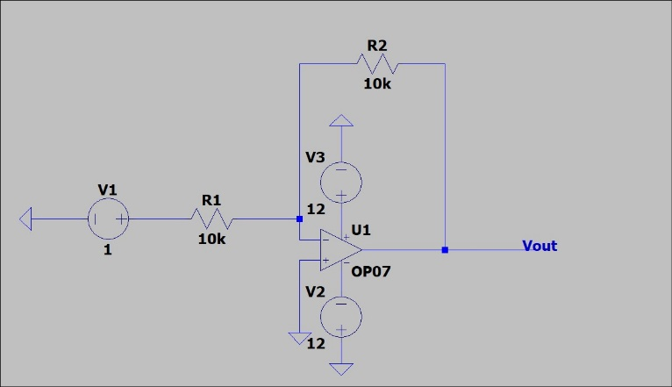

Non-Inverting Amplifier

a)

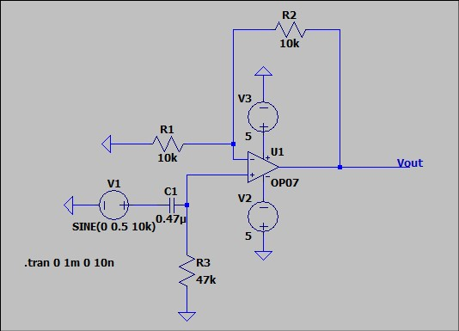

b) Frequency Response

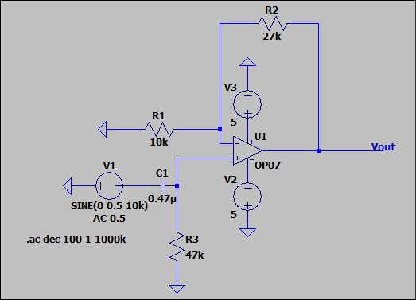

Voltage Follower

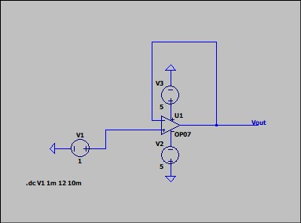

Adder

a)

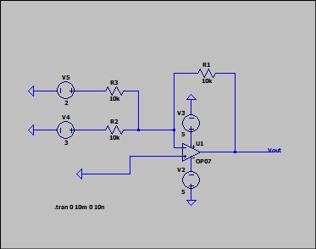

b)Summing Amplifier

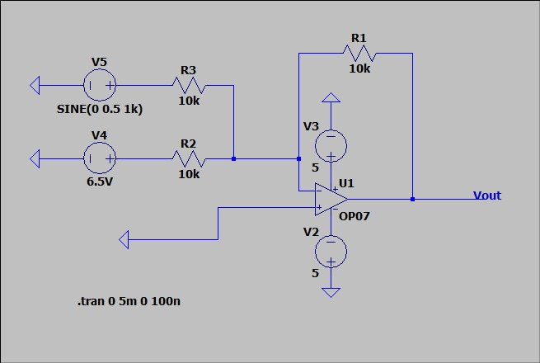

Superposition

a)

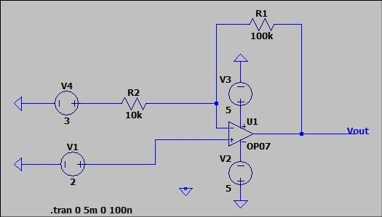

b)Differential Amplifier

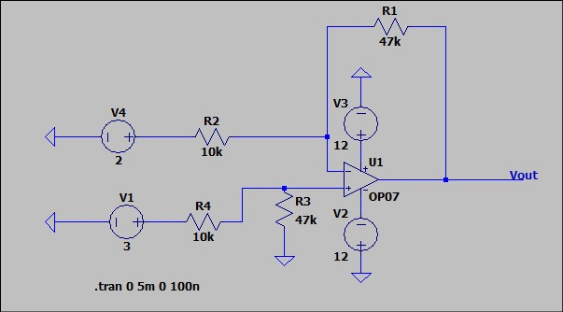

Integrator

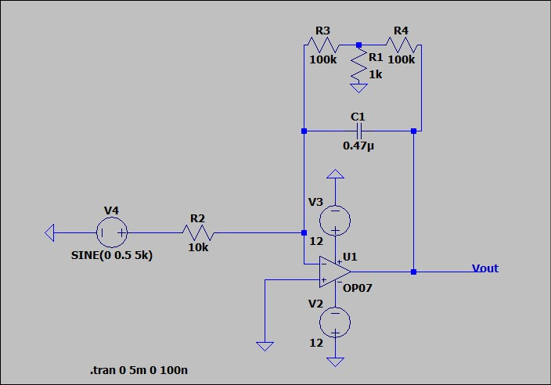

Differentiator

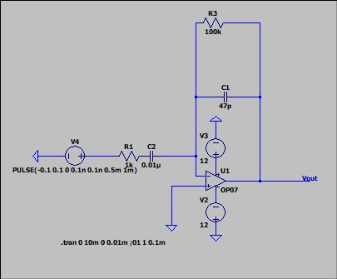

1. **Measurement Data (Tabular form)**

DC Gain

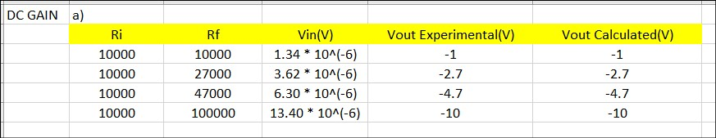

Non-Inverting Amplifier

a)

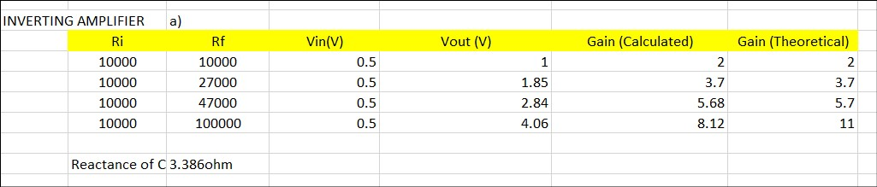

Superposition

a) 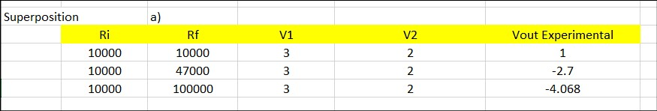

b)Differential Amplifier



1. **Graph (Image)/Screenshots**

Non-Inverting Amplifier

a)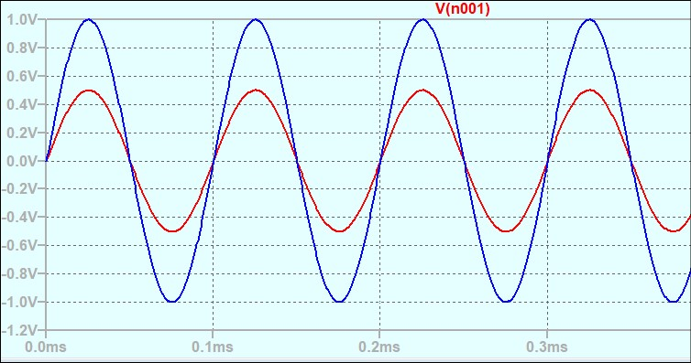

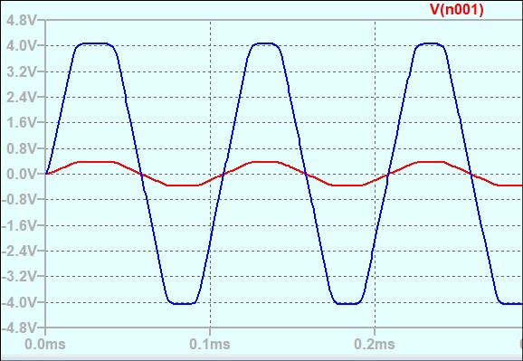

b) Frequency Response

Rf = 27K

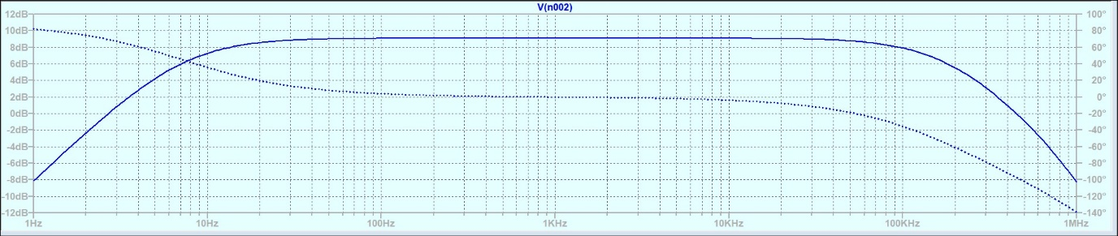

Rf = 47K

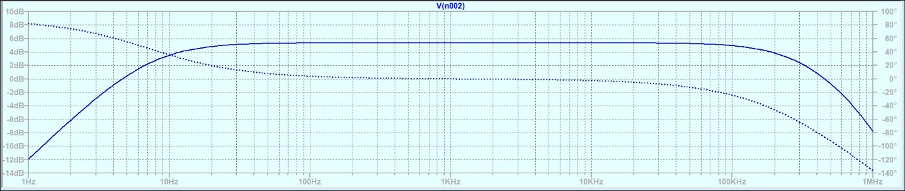

Rf=100K

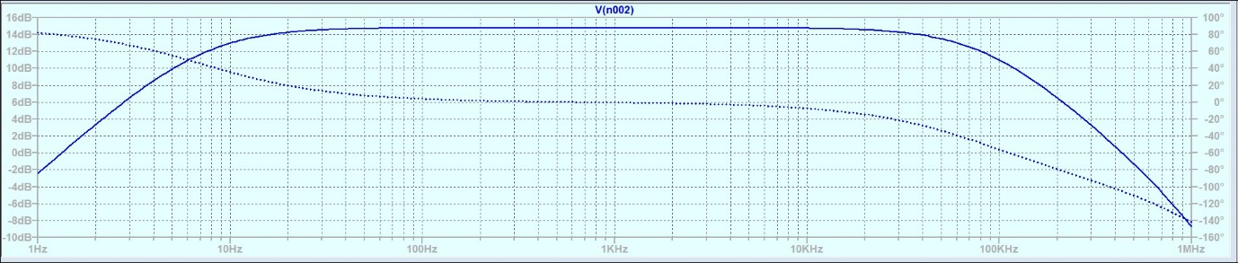

Voltage Follower

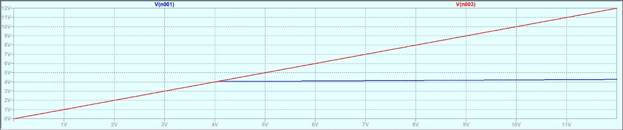

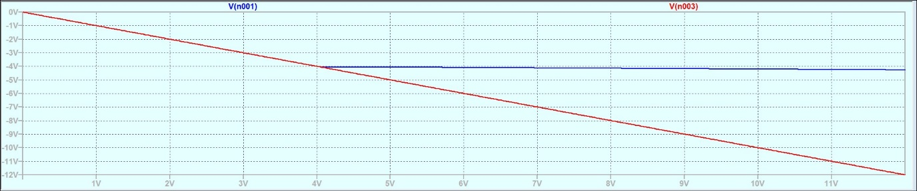

Adder

b)Summing Amplifier

for V=6.5V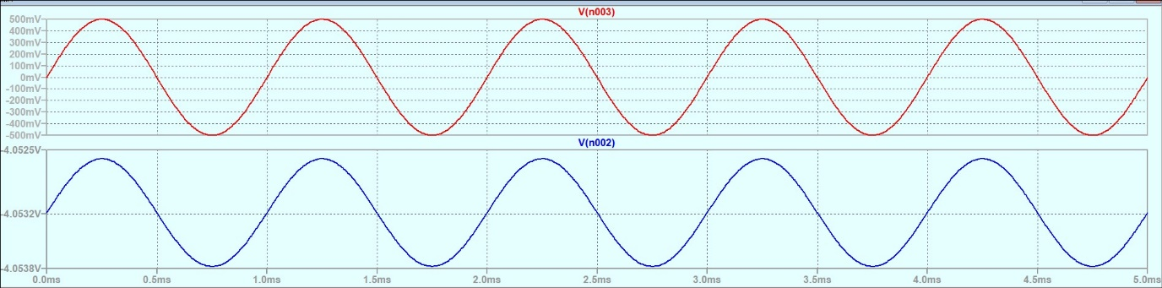

for V=3V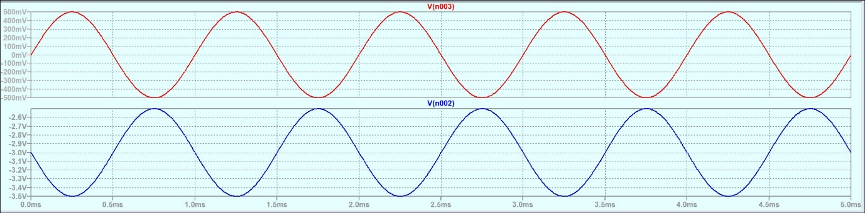

for V=-1V

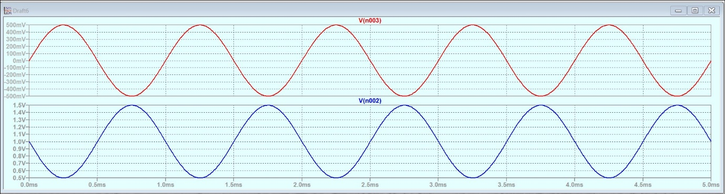

for V=-3V

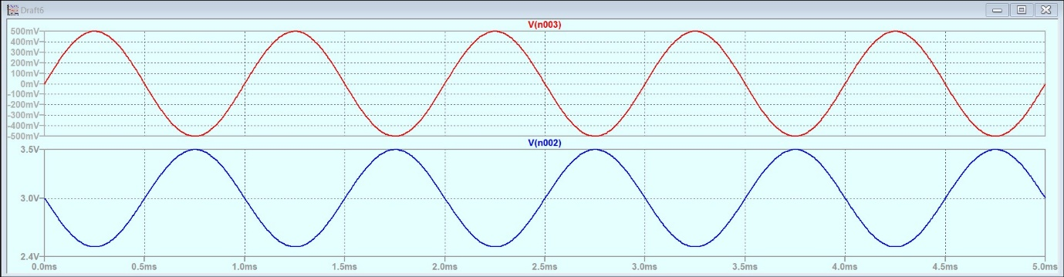

For V=-4.5V

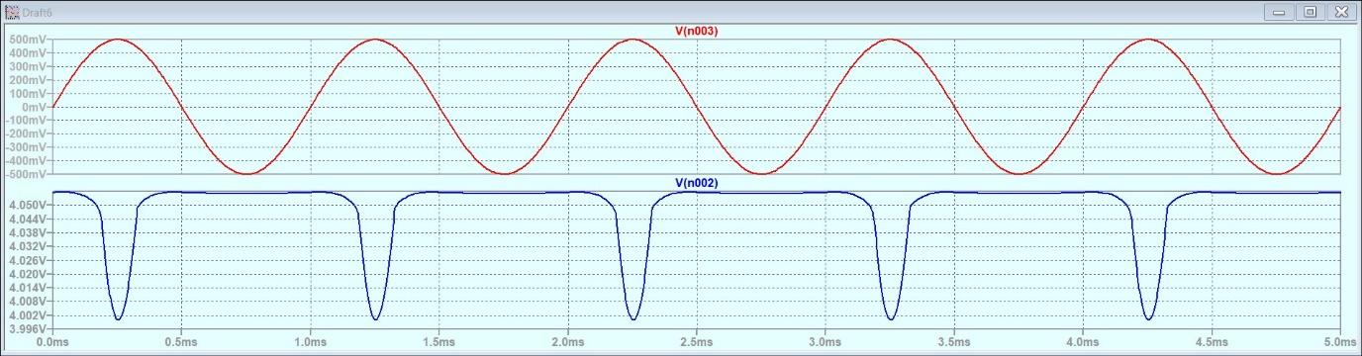

For V=-7.5V

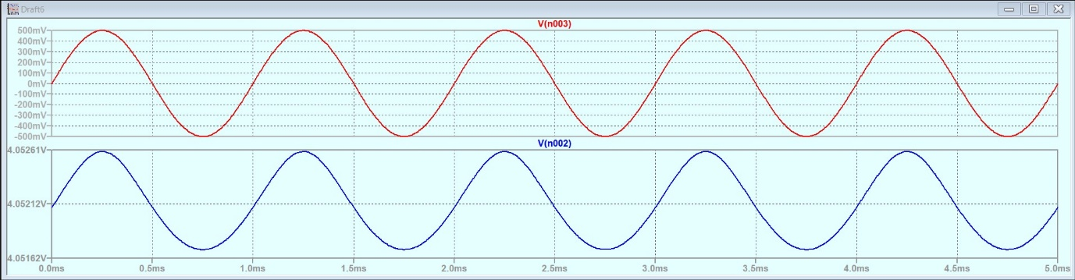

Integrator

For sine wave

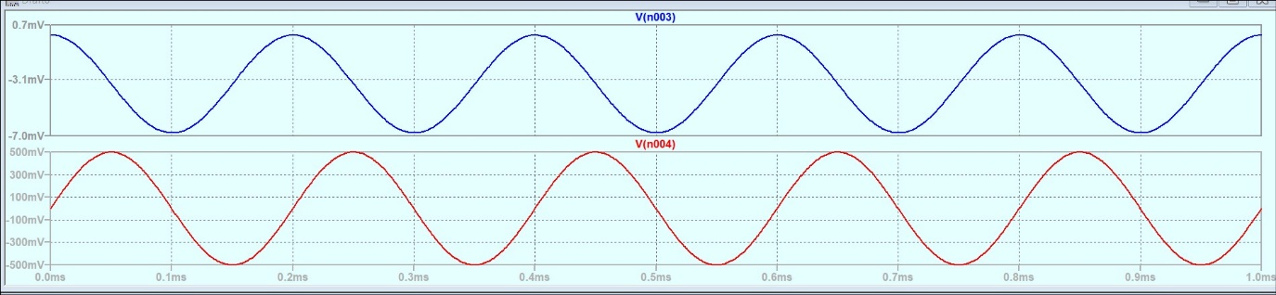

For square 5KHz

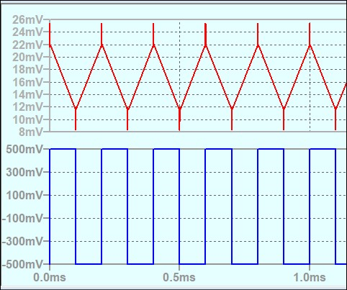

For square 10KHz

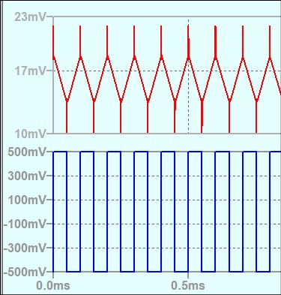

Differentiator

For square 1kHz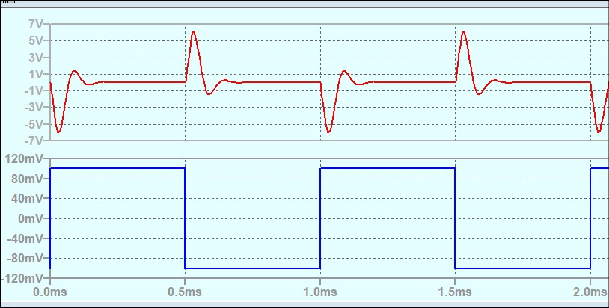

For square 10kHz

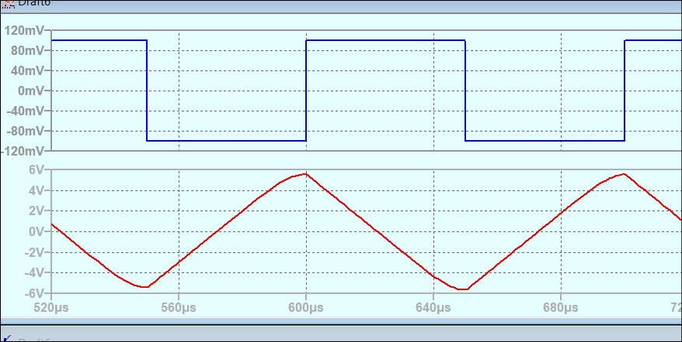

For sine 1kHz

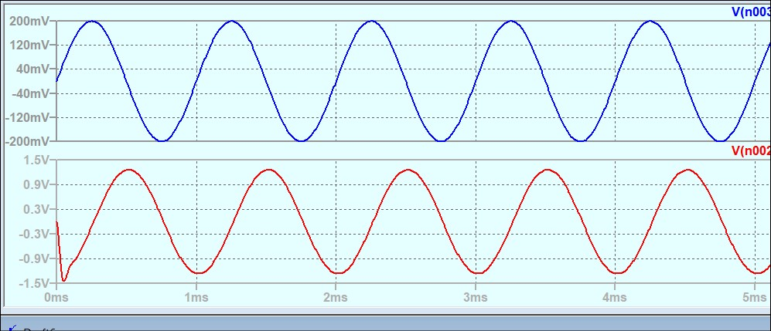

For triangular wave 1Khz

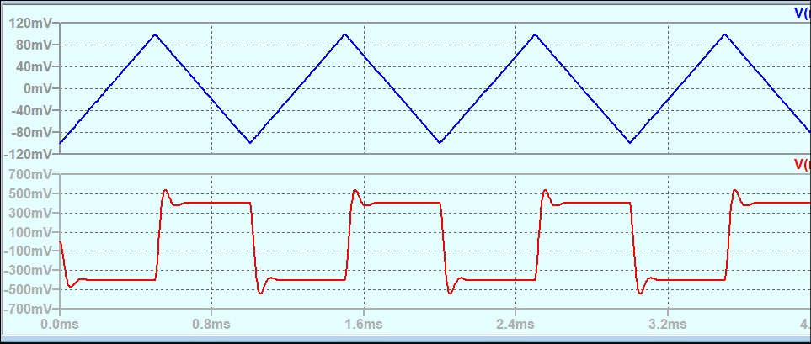

1. **Conclusion**

DC Gain

Hence we can say pin2 (inverting pin) is at virtual ground because the voltage at that point is close to 0V.

The value of Ii = (V1 – V1a)/Ri. As V1a is close to 0, we can say that the input impedance which is defined as Vin/Ii is almost equal to Ri.

Non-Inverting Amplifier

1. The output is non inverted for all the cases as the input is through the non-inverting pin. Only in the Rf = 100kohm, the output gets attenuated, due to reaching Vsaturation.

The gains (Vout/Vin) are near about 2, 3.7, 5.7, 8.12(attenuated) which is equal to the theoretical gain of (1 + Rf/Ri).

b) Frequency Response

For Rf = 27K ohm

Fl = 7.2 Hz

Fh = 305 KHz

Bandwidth ~ 305kHz

β = Ri/(Ri+Rf) = 0.27

At = gain ≈ 5.35db = 1.306

gain x bandwidth = 398.33 KHz

Ao = At/(1 – βxAt) = 2.06

For Rf = 47K ohm

Fl = 7.2 Hz

Fh = 177.4 KHz

Bandwidth ~ 177.4KHz

β = Ri/(Ri+Rf) = 0.175

At = gain ≈ 9.1db = 1.57

gain x bandwidth = 278.518 KHz

Ao = At/(1 – βxAt) = 2.164

For Rf = 100K ohm

Fl = 7.2 Hz

Fh = 84.1 KHz

Bandwidth ~ 84.1 KHz

β = Ri/(Ri+Rf) = 0.091

At = gain ≈ 14.8db = 2.096

gain x bandwidth = 176.27 KHz

Ao = At/(1 – βxAt) = 2.59

The higher gain circuits start to roll off faster as is evident from the bandwidths. As was established earlier higher Rf means higher gain. The Ao values also vary slightly with different gains.

Voltage Follower

The maximum and minimum voltages where the relationship is true is close to +- 4V. Beyond that the output voltage remains constant.

Inverting pin is not at virtual ground.

Adder

1. V1=2V

V2=3v

Vout = -4.055V

b)Summing Amplifier

The output voltage is shifted upwards or downwards by Vin keeping in mind that the maximum output voltage does not cross -5 V. Also as the input is at the inverting terminal, its shifted downwards for positive Vin and upwards for negative Vin.

Superposition

1. The output is the algebraic sum of the individual outputs as proposed by Superposition Theorem

b)Differential Amplifier

The output voltage therefore follows the formula shown above as the output voltage is considerably below the V saturation.

Integrator

The output voltage looks as if it has been integrated. As the input is on the inverting terminal, the output is also inverted.

Differentiator

As we can see the output waveform is as if the input waveform has been differentiated. The output waveform is also 180° out of phase i.e inverted

1. **Discussions**

1. The biasing voltage needs to be kept in mind while using Op Amp as the saturation voltage is controlled by the biasing voltage.

2. The biasing voltage cannot be too high or too low otherwise the Op Amp would not be in the active region and erroneous results might be obtained.

3. The Rf/Ri ratio cannot be too high otherwise the maximum value of the output signal might exceed the saturation voltage and erroneous results might be obtained.

4. Transient effects are possible for a short period of time. Steady state is achieved after a suitable amount of time from where the observations should be noted.